Front-End UI/UX Mini Project

# Harry Potter Movie Series Info Page

# 1. Title Page

**Project Title:** Harry Potter Movie Series Info Page

**Submitted By:**

Anindita Saha  
Roll Number: 2460328  
College Email: [anindita.saha@btech.christuniversity.in](mailto:anindita.saha@btech.christuniversity.in)

Jessica John Osta

Roll Number:2460376

College Email: [jessica.john@btech.christuniversity.in](mailto:jessica.john@btech.christuniversity.in)

**Course:** UI/UX Design Fundamentals

**Instructor Name:** Ms. Nagaveena

**Institution:** Christ (Deemed to be University)

**Date of Submission:** 13/08/2025

# 2. Abstract

This project is a visually captivating single-page website dedicated to the complete Harry Potter movie series. It showcases detailed information about all eight films, including plot summaries, cast members, reviews, and streaming platforms. The design incorporates a magical, dark-themed color palette inspired by the Wizarding World, with iconic imagery such as Hogwarts, wands, and spells. **HTML5** and **CSS3** were used for structure and styling, while **Flexbox** and **Grid managed** the cast and review layouts. The website is fully responsive, ensuring an immersive and accessible experience across all devices.

# 3. Objectives

• Design a Harry Potter-themed single-page website capturing the magical essence of the series.

• Present detailed movie information for all eight films, including plots, cast, and reviews.

• Implement responsive layouts using **HTML5 and CSS3 with Flexbox/Grid**.

• Incorporate thematic visuals, including movie posters, character images, and Hogwarts-inspired fonts.

• Maintain accessibility with readable fonts and high-contrast colors.

# 4. Scope of the Project

• Focused exclusively on front-end design, without **JavaScript** or backend integration.

• Ensures responsive design for desktop, tablet, and mobile devices.

• Incorporates a magical dark color theme with Harry Potter typography and visuals.

• Uses only open-source tools and pure **HTML/CSS.**

# 5. Tools & Technologies Used

|  |  |
| --- | --- |
| **Tool/Technology** | **Purpose** |
| HTML5 | Markup and content structure for the Harry Potter movie page |
| CSS3 | Styling, layout, and magical visual effects |
| VS Code | Code editor for development |
| Chrome DevTools | Testing and debugging responsiveness and styles |

# 6. HTML Structure Overview

• Used semantic tags: ***<header>, <nav>, <main>, <section>, <footer>.***

• Sections include: Header, Banner (Hogwarts image), Synopsis, Cast, Reviews, Where to Watch, Footer.

• Navigation menu created with ***<ul>*** and anchor links for smooth scrolling.

• Organized reusable sections for each movie in the series.

# 7. CSS Styling Strategy

• Used external **CSS** file (movie.css) for styling.

• Magical dark theme with gold accents, inspired by Hogwarts.

• Applied **Flexbox and Grid** for organizing cast photos and reviews.

• Used **CSS** variables for theme customization.

• Hover effects, glowing transitions, and **CSS-based** star ratings.

• Media Queries for responsiveness across devices.

# 8. Key Features

|  |  |
| --- | --- |
| **Feature** | **Description** |
| Responsive Design | Adapts seamlessly to all screen sizes and devices. |
| Magical Theme | Dark mode with gold accents, Hogwarts-inspired fonts, and wizard imagery. |
| Smooth Navigation | Fixed top navigation bar with anchor links to each section. |
| Movie Sections | Separate synopsis, cast list, and reviews for each of the eight films. |
| Cast Grid | Flexbox/Grid layout showcasing actors and roles. |
| Where to Watch | List of streaming platforms with clickable logos. |

# 9. Challenges Faced & Solutions

|  |  |
| --- | --- |
| **Challenge** | **Solution** |
| Maintaining visual clarity in a dark theme | Used gold and light-colored text for contrast. |
| Overlapping elements on small screens | Used media queries to adjust layout. |
| Difficulty aligning cast images | Used Flexbox/Grid for better control. |
| Keeping file size small with many images | Optimized images without losing quality. |

# 10. Outcome

* **A fully responsive, single-page Harry Potter-themed website** that adapts seamlessly to desktops, tablets, and mobile devices.
* **An immersive, cinematic user interface** featuring Hogwarts-inspired fonts, dark mode with gold accents, and magical visual effects.
* **Comprehensive movie series information** including synopses, cast details, reviews, and streaming availability for all eight films.
* **Enhanced front-end development skills** in HTML5, CSS3, Flexbox, and Grid, with an emphasis on thematic design and multimedia integration.

# 11. Future Enhancements

* **Add interactive elements using JavaScript** such as search functionality, movie filters, or collapsible sections for each film.
* **Integrate a functional contact or feedback form** for user reviews and ratings submission.
* **Include animated transitions and effects** like floating candles, spell animations, or interactive Hogwarts map.
* **Embed multimedia content** such as official trailers, behind-the-scenes videos, and soundtrack previews.
* **Implement a dark/light mode toggle** for better accessibility and user preference.
* **Add multilingual support** to make the website accessible to a global audience of Harry Potter fans.

# 12. Sample Code ( HTML & CSS )

## HTML

<!DOCTYPE html>

<html lang="en">

<head>

  <meta charset="utf-8" />

  <meta name="viewport" content="width=device-width,initial-scale=1" />

  <title>Harry Potter — The Film Series</title>

  <!-- Fonts -->

  <link href="https://fonts.googleapis.com/css2?family=Cinzel+Decorative:wght@700&family=EB+Garamond&display=swap" rel="stylesheet">

  <!-- Main stylesheet -->

  <link rel="stylesheet" href="css/movie.css">

</head>

<body id="home">

  <!-- NAV (parchment styled) -->

  <nav class="parchment-nav" role="navigation" aria-label="Main navigation">

    <a href="#home">Home</a>

    <a href="#characters">Characters</a>

    <a href="#synopsis">Plot</a>

    <a href="#movies">Movies</a>

    <a href="#gallery">Gallery</a>

    <a href="#trailer">Trailer</a>

    <a href="#reviews">Reviews</a>

    <a href="#creators">Creators</a>

  </nav>

  <!-- HERO: Hogwarts at night + mist + title -->

  <header class="hero" id="hero" style="background-image:url('images/hog4.png')">

    <div class="mist" aria-hidden="true"></div>

    <div class="hero-inner">

      <img class="thumb" src="images/Three.png" alt="Harry Potter series poster thumbnail">

      <div class="hero-text">

        <h1 class="hp-title">Harry Potter</h1>

        <p class="hero-sub">The Magical Journey of The Boy Who Lived — 2001–2011</p>

        <p class="hero-subsmall">A cinematic saga of friendship, courage, and sacrifice</p>

      </div>

    </div>

  </header>

  <!-- SYNOPSIS (scroll-like) -->

  <section id="synopsis" class="section synopsis">

    <h2 class="section-title">Series Synopsis (Scroll)</h2>

    <div class="scroll">

      <p>The Harry Potter saga follows an orphaned boy who discovers he is a wizard and is introduced to a hidden magical world. Over eight films Harry matures from curious child to leader of a resistance against Lord Voldemort. Friendship, sacrifice, and the cost of love drive the story forward as Hogwarts itself becomes a living, breathing character. The saga weaves wonder, danger, and heartbreak across dozens of unforgettable set pieces. It culminates in a final struggle where ordinary courage meets extraordinary destiny.</p>

    </div>

  </section>

  <!-- CHARACTERS -->

  <section id="characters" class="section characters">

    <h2 class="section-title">Characters</h2>

    <div class="char-grid">

      <!-- Main Trio (Gryffindor) -->

      <article class="character-card gryffindor">

        <img src="images/Harry.png" alt="Harry Potter">

        <h4>Harry Potter</h4>

        <div class="house-label">

    <span class="dot gryffindor"></span> Gryffindor

  </div>

        <p>The Boy Who Lived — brave, compassionate, and destined to face Voldemort. He learns leadership, loss and the value of choices.</p>

      </article>

      <article class="character-card gryffindor">

        <img src="images/hermione.png" alt="Hermione Granger">

        <h4>Hermione Granger</h4>

        <div class="house-label">

    <span class="dot gryffindor"></span> Gryffindor

  </div>

        <p>Brilliant witch and the trio's strategist — fiercely moral, resourceful, and devoted to equality for all magical folk.</p>

      </article>

      <article class="character-card gryffindor">

        <img src="images/ron.png" alt="Ron Weasley">

        <h4>Ron Weasley</h4>

        <div class="house-label">

    <span class="dot gryffindor"></span> Gryffindor

  </div>

        <p>Loyal best friend — warm, humorous and courageous in his own, grounded way. Family and friendship define him.</p>

      </article>

      <!-- Hogwarts Staff & Allies -->

      <article class="character-card gryffindor">

        <img src="images/albusDumbledore.png.png" alt="Albus Dumbledore">

        <h4>Albus Dumbledore</h4>

        <div class="house-label">

    <span class="dot gryffindor"></span> Gryffindor

  </div>

        <p>Headmaster of Hogwarts — wise, complex, and willing to shoulder hard decisions for the greater good.</p>

      </article>

      <article class="character-card gryffindor">

        <img src="images/Minerva McGonagall.png" alt="Minerva McGonagall">

        <h4>Minerva McGonagall</h4>

        <div class="house-label">

    <span class="dot gryffindor"></span> Gryffindor

  </div>

        <p>Deputy Headmistress — stern, principled and fiercely protective of her students and Hogwarts.</p>

      </article>

      <article class="character-card slytherin">

        <img src="images/Severus Snape .png" alt="Severus Snape">

        <h4>Severus Snape</h4>

        <div class="house-label">

    <span class="dot slytherin"></span> Slytherin

  </div>

        <p>Potions Master with complex loyalties — ultimately tragic and revealed to have acted out of love and duty.</p>

      </article>

      <article class="character-card gryffindor">

        <img src="images/Rubeus Hagrid .png" alt="Rubeus Hagrid">

        <h4>Rubeus Hagrid</h4>

        <div class="house-label">

    <span class="dot gryffindor"></span> Gryffindor

  </div>

        <p>Keeper of Keys & Grounds — giant-hearted, devoted to magical creatures and to Harry like family.</p>

      </article>

      <article class="character-card gryffindor">

        <img src="images/Remus Lupin.png" alt="Remus Lupin">

        <h4>Remus Lupin</h4>

        <div class="house-label">

    <span class="dot gryffindor"></span> Gryffindor

  </div>

        <p>Defence Against the Dark Arts professor — kind, wise and burdened by lycanthropy.</p>

      </article>

      <article class="character-card ravenclaw">

        <img src="images/Sybill Trelawney.png" alt="Sybill Trelawney">

        <h4>Sybill Trelawney</h4>

        <div class="house-label">

    <span class="dot ravenclaw"></span> Ravenclaw

  </div>

        <p>Divination professor — eccentric yet linked to key prophecies in the saga.</p>

      </article>

      <!-- Weasley Family -->

      <article class="character-card gryffindor">

        <img src="images/Ginny Weasley.png" alt="Ginny Weasley">

        <h4>Ginny Weasley</h4>

        <div class="house-label">

    <span class="dot gryffindor"></span> Gryffindor

  </div>

        <p>Skilled witch and Harry’s love interest — brave, independent, and a strong fighter.</p>

      </article>

      <article class="character-card gryffindor">

        <img src="images/Fred & George Weasley.png" alt="Fred Weasley">

        <h4>Fred Weasley</h4>

        <div class="house-label">

    <span class="dot gryffindor"></span> Gryffindor

  </div>

        <p>One half of the prankster twins — inventive, brave, and beloved.</p>

      </article>

      <article class="character-card gryffindor">

        <img src="images/Fred & George Weasley.png" alt="George Weasley">

        <h4>George Weasley</h4>

        <div class="house-label">

    <span class="dot gryffindor"></span> Gryffindor

  </div>

        <p>Fred’s twin and business partner — irreverent and entrepreneurial.</p>

      </article>

      <article class="character-card gryffindor">

        <img src="images/Arthur Weasley.png" alt="Arthur Weasley">

        <h4>Arthur Weasley</h4>

        <div class="house-label">

    <span class="dot gryffindor"></span> Gryffindor

  </div>

        <p>Curious Ministry worker fascinated by Muggles, devoted to family and decency.</p>

      </article>

      <article class="character-card gryffindor">

        <img src="images/Molly Weasley.png" alt="Molly Weasley">

        <h4>Molly Weasley</h4>

        <div class="house-label">

    <span class="dot gryffindor"></span> Gryffindor

  </div>

        <p>Maternal and fierce — a loving hearth and a fearsome defender of family.</p>

      </article>

      <article class="character-card gryffindor">

        <img src="images/Percy Weasley.png" alt="Percy Weasley">

        <h4>Percy Weasley</h4>

        <div class="house-label">

    <span class="dot gryffindor"></span> Gryffindor

  </div>

        <p>Ambitious Ministry official who learns the price of pride and the value of forgiveness.</p>

      </article>

      <article class="character-card gryffindor">

        <img src="images/Bill & Charlie Weasley.png" alt="Bill Weasley">

        <h4>Bill Weasley</h4>

        <div class="house-label">

    <span class="dot gryffindor"></span> Gryffindor

  </div>

        <p>Gringotts curse-breaker — pragmatic, brave and married into the world of curses.</p>

      </article>

      <article class="character-card gryffindor">

        <img src="images/Bill & Charlie Weasley.png" alt="Charlie Weasley">

        <h4>Charlie Weasley</h4>

        <div class="house-label">

    <span class="dot gryffindor"></span> Gryffindor

  </div>

        <p>Dragon expert — adventurous and devoted to magical creatures abroad.</p>

      </article>

      <!-- Order of the Phoenix -->

      <article class="character-card gryffindor">

        <img src="images/Sirius Black .png" alt="Sirius Black">

        <h4>Sirius Black</h4>

        <div class="house-label">

    <span class="dot gryffindor"></span> Gryffindor

  </div>

        <p>Harry’s godfather — reckless, beloved and tragically lost to war.</p>

      </article>

      <article class="character-card gryffindor">

        <img src="images/Alastor “Mad-Eye” Moody.png" alt="Mad-Eye Moody">

        <h4>Alastor “Mad-Eye” Moody</h4>

        <div class="house-label">

    <span class="dot gryffindor"></span> Gryffindor

  </div>

        <p>Legendary Auror — battle-hardened and tireless in defence of others.</p>

      </article>

      <article class="character-card gryffindor">

        <img src="images/Nymphadora Tonks .png" alt="Nymphadora Tonks">

        <h4>Nymphadora Tonks</h4>

        <div class="house-label">

    <span class="dot gryffindor"></span> Gryffindor

  </div>

        <p>Metamorphmagus Auror — playful, loyal and tragically romantic.</p>

      </article>

      <article class="character-card gryffindor">

        <img src="images/Kingsley Shacklebolt.png" alt="Kingsley Shacklebolt">

        <h4>Kingsley Shacklebolt</h4>

        <div class="house-label">

    <span class="dot gryffindor"></span> Gryffindor

  </div>

        <p>Calm Auror who later helps rebuild the Ministry and restore justice.</p>

      </article>

      <!-- Students -->

      <article class="character-card gryffindor">

        <img src="images/Neville Longbottom.png" alt="Neville Longbottom">

        <h4>Neville Longbottom</h4>

        <div class="house-label">

    <span class="dot gryffindor"></span> Gryffindor

  </div>

        <p>Grows from timid pupil into courageous leader — a late-blooming hero.</p>

      </article>

      <article class="character-card ravenclaw">

        <img src="images/luna2.png" alt="Luna Lovegood">

        <h4>Luna Lovegood</h4>

        <div class="house-label">

    <span class="dot ravenclaw"></span> Ravenclaw

  </div>

        <p>Quirky Ravenclaw — kind, perceptive and quietly brave.</p>

      </article>

      <article class="character-card ravenclaw">

        <img src="images/Cho Chang.png" alt="Cho Chang">

        <h4>Cho Chang</h4>

        <div class="house-label">

    <span class="dot ravenclaw"></span> Ravenclaw

  </div>

        <p>Ravenclaw Seeker — Harry’s early love interest whose grief shapes her arc.</p>

      </article>

      <article class="character-card hufflepuff">

        <img src="images/Cedric Diggory .png" alt="Cedric Diggory">

        <h4>Cedric Diggory</h4>

        <div class="house-label">

    <span class="dot hufflepuff"></span> Hufflepuff

  </div>

        <p>Noble Hufflepuff — fair, brave and tragically young when lost.</p>

      </article>

      <article class="character-card slytherin">

        <img src="images/draco2.png" alt="Draco Malfoy">

        <h4>Draco Malfoy</h4>

        <div class="house-label">

    <span class="dot slytherin"></span> Slytherin

  </div>

        <p>Privileged Slytherin — rival to Harry, shaped by family and fear.</p>

      </article>

      <article class="character-card slytherin">

        <img src="images/Pansy Parkinson.png" alt="Pansy Parkinson">

        <h4>Pansy Parkinson</h4>

        <div class="house-label">

    <span class="dot slytherin"></span> Slytherin

  </div>

        <p>Slytherin student — loyal within her social circle and often harsh.</p>

      </article>

      <!-- Villains & Other Key Figures -->

      <article class="character-card slytherin">

        <img src="images/Lord Voldemort (Tom Riddle).png" alt="Lord Voldemort">

        <h4>Lord Voldemort</h4>

        <div class="house-label">

    <span class="dot slytherin"></span> Slytherin

  </div>

        <p>The Dark Lord — obsessed with immortality and domination; the central antagonist.</p>

      </article>

      <article class="character-card slytherin">

        <img src="images/Bellatrix Lestrange.png" alt="Bellatrix Lestrange">

        <h4>Bellatrix Lestrange</h4>

        <div class="house-label">

    <span class="dot slytherin"></span> Slytherin

  </div>

        <p>Fanatic Death Eater — violent, unpredictable and terrifyingly devoted.</p>

      </article>

      <article class="character-card slytherin">

        <img src="images/Lucius Malfoy.png" alt="Lucius Malfoy">

        <h4>Lucius Malfoy</h4>

        <div class="house-label">

    <span class="dot slytherin"></span> Slytherin

  </div>

        <p>Wealthy Death Eater — manipulative and politically ambitious.</p>

      </article>

      <article class="character-card slytherin">

        <img src="images/Peter Pettigrew (Wormtail) .png" alt="Peter Pettigrew">

        <h4>Peter Pettigrew</h4>

        <div class="house-label">

    <span class="dot slytherin"></span> Slytherin

  </div>

        <p>Betrayer of Harry’s parents — cowardly and treacherous in service of Voldemort.</p>

      </article>

      <article class="character-card slytherin">

        <img src="images/Barty Crouch Jr..png" alt="Barty Crouch Jr.">

        <h4>Barty Crouch Jr.</h4>

        <div class="house-label">

    <span class="dot slytherin"></span> Slytherin

  </div>

        <p>Deceptive Death Eater who played a key, dangerous role in Voldemort’s return.</p>

      </article>

      <article class="character-card creature">

        <img src="images/Dobby .png" alt="Dobby">

        <h4>Dobby</h4>

        <div class="house-label">

    <span class="dot creature"></span> Creature

  </div>

        <p>Free house-elf — brave, selfless, and deeply loyal to Harry.</p>

      </article>

      <article class="character-card creature">

        <img src="images/kreacher.png" alt="Kreacher">

        <h4>Kreacher</h4>

        <div class="house-label">

    <span class="dot creature"></span> Creature

  </div>

        <p>House-elf of the Black family — surly, resentful, and ultimately helpful.</p>

      </article>

    </div>

  </section>

  <!-- MOVIES -->

  <section id="movies" class="section movies">

    <h2 class="section-title">Films — Summaries, Runtime & Ratings</h2>

    <div class="movie-grid">

      <article class="movie">

        <img src="images/sorcerers-stone.png" alt="Sorcerer's Stone poster">

        <h3>Harry Potter and the Sorcerer's Stone (2001)</h3>

        <p>Harry discovers he is a wizard and is invited to Hogwarts. He forms early bonds with Ron and Hermione and learns about his parents' legacy. Strange occurrences around a hidden stone hint at deeper darkness. The trio uncovers secrets beneath the school and faces clever traps. Harry confronts Voldemort’s lingering threat for the first time. This opening chapter introduces wonder, friendship, and the moral stakes that follow.</p>

        <p><strong>Runtime:</strong> 2h 32m</p>

        <p><strong>Release Date:</strong> November 16, 2001</p>

        <p><strong>Customer Rating:</strong> 8.1 / 10 — ★★★★☆</p>

      </article>

      <article class="movie">

        <img src="images/chamber-of-secrets.png" alt="Chamber of Secrets poster">

        <h3>Harry Potter and the Chamber of Secrets (2002)</h3>

        <p>Harry returns to Hogwarts despite warnings and hears unsettling voices in the walls. Students are petrified and horror spreads as the Chamber’s legend awakens. The trio investigates, discovering hidden passages and a deadly basilisk. Tom Riddle’s diary reveals a youthful Voldemort and his cruelty. Harry faces the basilisk and destroys the memory-curse object. This film deepens the series’ darker mythology while testing the bonds of friendship.</p>

        <p><strong>Runtime:</strong> 2h 41m</p>

        <p><strong>Release Date:</strong> November 15, 2002</p>

        <p><strong>Customer Rating:</strong> 7.4 / 10 — ★★★☆</p>

      </article>

      <article class="movie">

        <img src="images/prisoner-of-azkaban.png" alt="Prisoner of Azkaban poster">

        <h3>Harry Potter and the Prisoner of Azkaban (2004)</h3>

        <p>Rumors swirl that Sirius Black, an escaped convict, is after Harry; Dementors patrol Hogwarts. Truths about betrayal and friendship begin to surface through startling revelations. Time travel is used to save lives and rewrite a small slice of history. Lupin’s tragic affliction and Sirius’s loyalty complicate the tale. The emotional stakes rise as Harry learns more about his parents’ past. This installment adds moral ambiguity and haunting atmosphere.</p>

        <p><strong>Runtime:</strong> 2h 22m</p>

        <p><strong>Release Date:</strong> June 4, 2004</p>

        <p><strong>Customer Rating:</strong> 8.0 / 10 — ★★★★☆</p>

      </article>

      <article class="movie">

        <img src="images/goblet-of-fire.png" alt="Goblet of Fire poster">

        <h3>Harry Potter and the Goblet of Fire (2005)</h3>

        <p>Harry is unexpectedly entered into the perilous Triwizard Tournament amid rising tensions. He endures dragons, mermaid lagoons, and a deadly maze under punishing scrutiny. Friendships are strained and alliances shift with international competitors. The contest culminates in a shocking resurrection sequence that restores Voldemort’s full power. The wizarding world can no longer deny the return of darkness. Stakes escalate as adolescence collides with global peril.</p>

        <p><strong>Runtime:</strong> 2h 37m</p>

        <p><strong>Release Date:</strong> November 18, 2005</p>

        <p><strong>Customer Rating:</strong> 7.7 / 10 — ★★★★☆</p>

      </article>

      <article class="movie">

        <img src="images/order-of-the-phoenix.png" alt="Order of the Phoenix poster">

        <h3>Harry Potter and the Order of the Phoenix (2007)</h3>

        <p>The Ministry denies Voldemort’s return, stifling truth and empowering corruption within Hogwarts. Harry and Dumbledore’s warnings are dismissed, prompting a student-led resistance: Dumbledore’s Army. Dolores Umbridge’s authoritarian rule suffocates the school with cruelty and censorship. Harry’s visions connect painfully to Voldemort, leading to a catastrophic battle at the Ministry. Loss strikes home with Sirius’s death, changing Harry irrevocably. The film marks a transition from school-year tales to outright war.</p>

        <p><strong>Runtime:</strong> 2h 18m</p>

        <p><strong>Release Date:</strong> July 11, 2007</p>

        <p><strong>Customer Rating:</strong> 7.5 / 10 — ★★★★☆</p>

      </article>

      <article class="movie">

        <img src="images/half-blood-prince.png" alt="Half-Blood Prince poster">

        <h3>Harry Potter and the Half-Blood Prince (2009)</h3>

        <p>Darkness spreads as Dumbledore recruits Harry to learn about Voldemort’s past and Horcruxes. Romance, jealousy, and teenage complexities thread through rising dread. The hunt for Horcruxes reveals fragments of the Dark Lord’s soul and methodical cruelty. Trust fractures and loyalties are tested within Hogwarts’ walls. A stunning betrayal culminates in Dumbledore’s tragic fall. The film sets the emotional and tactical stage for the final confrontation.</p>

        <p><strong>Runtime:</strong> 2h 33m</p>

        <p><strong>Release Date:</strong> July 15, 2009</p>

        <p><strong>Customer Rating:</strong> 7.6 / 10 — ★★★★☆</p>

      </article>

      <article class="movie">

        <img src="images/deathly-hallows-part1.png" alt="Deathly Hallows Part 1 poster">

        <h3>Harry Potter and the Deathly Hallows – Part 1 (2010)</h3>

        <p>Harry, Ron, and Hermione leave school and embark on a perilous quest to destroy Horcruxes. On the run, they face fear, betrayal, deprivation, and doubt. The legend of the Deathly Hallows surfaces and tempts with false power. Their friendship is strained by the weight of responsibility and secrets revealed. Loss mounts as the world falls under Voldemort’s control and hope thins. The film emphasises endurance and the quiet heroism of ordinary acts.</p>

        <p><strong>Runtime:</strong> 2h 26m</p>

        <p><strong>Release Date:</strong> November 19, 2010</p>

        <p><strong>Customer Rating:</strong> 7.7 / 10 — ★★★★☆</p>

      </article>

      <article class="movie">

        <img src="images/deathly-hallows-part2.png" alt="Deathly Hallows Part 2 poster">

        <h3>Harry Potter and the Deathly Hallows – Part 2 (2011)</h3>

        <p>The final showdown erupts in a colossal Battle of Hogwarts as allies gather to resist the Dark Lord. Long-hidden truths about love, loyalty, and Snape’s motives come to light in poignant revelations. Horcruxes are destroyed at great cost, and bravery shines in many unexpected forms. Harry confronts Voldemort in an ultimate duel that resolves prophecy and sacrifice. The battle’s end brings painful losses but also restoration and new beginnings. The saga closes with hope, healing, and a glimpse of the next generation.</p>

        <p><strong>Runtime:</strong> 2h 10m</p>

        <p><strong>Release Date:</strong> July 15, 2011</p>

        <p><strong>Customer Rating:</strong> 8.1 / 10 — ★★★★☆</p>

      </article>

    </div>

  </section>

  <!-- GALLERY -->

  <section id="gallery" class="section gallery">

    <h2 class="section-title">Gallery</h2>

    <div class="gallery-grid">

      <img src="images/hoggi5.png" alt="Hogwarts">

      <img src="images/harryscene.png" alt="harry Potter scene">

      <img src="images/quote.png" alt="Quote by Hagrid">

    </div>

  </section>

  <!-- TRAILER & TRIVIA -->

  <section id="trailer" class="section trailer-trivia">

    <h2 class="section-title">Trailer & Trivia</h2>

    <div class="trailer-wrap">

      <div class="enchanted-frame" style="background-image:url('images/video-frame.png')">

        <iframe src="video/The Harry Potter Movies in Six Minutes.mp4.mp4" title="Harry Potter Preview" allowfullscreen></iframe>

      </div>

    </div>

    <div class="trivia">

      <h4>Fun Trivia</h4>

      <ul>

        <li>Many props and costumes were handmade to create a lived-in, realistic magical world.</li>

        <li>Several cast members returned across multiple films, which helped sustain the series' continuity.</li>

      </ul>

    </div>

  </section>

  <!-- REVIEWS -->

  <section id="reviews" class="section reviews">

    <h2 class="section-title">Fan Reviews</h2>

    <div class="reviews-grid">

      <div class="review-card"><p>“A timeless saga — I grew up with these films and they still move me.”</p><div class="stars">★★★★★</div><small>— Anna</small></div>

      <div class="review-card"><p>“Spectacle, heart, and unforgettable characters.”</p><div class="stars">★★★★☆</div><small>— Ben</small></div>

      <div class="review-card"><p>“Visually gorgeous and emotionally deep.”</p><div class="stars">★★★★★</div><small>— Cara</small></div>

      <div class="review-card"><p>“A perfect blend of fantasy and coming-of-age.”</p><div class="stars">★★★★★</div><small>— Dev</small></div>

      <div class="review-card"><p>“Some parts are darker than I expected — in a good way.”</p><div class="stars">★★★★☆</div><small>— Emma</small></div>

    </div>

  </section>

  <!-- CREATORS: Director + Writer -->

  <section id="creators" class="section creators">

    <h2 class="section-title">Behind the Magic</h2>

    <div class="creators-grid">

      <div class="creator-card">

        <img src="images/chris.png" alt="Chris Columbus">

        <h4>Chris Columbus</h4>

        <p>Director of the first two Harry Potter films — set the warm, wonder-filled tone of the cinematic world.</p>

        <p>Guided the young cast through their breakout performances and established a faithful screen vision of Hogwarts.</p>

      </div>

      <div class="creator-card">

        <img src="images/jkrowlin.png" alt="J.K. Rowling">

        <h4>J.K. Rowling</h4>

        <p>Author of the Harry Potter books — created the layered world of Hogwarts and the moral backbone of the saga.</p>

        <p>Her storytelling balances whimsy with weighty themes of love, loss, identity, and choice.</p>

        <p>The books inspired the films and continue to influence global popular culture and new generations of readers.</p>

      </div>

    </div>

  </section>

  <!-- FOOTER: candles + symbols -->

  <footer class="site-footer">

    <div class="footer-inner">

      <img src="images/magical-symbols.png" alt="Magical Symbols" class="symbols">

      <div class="candles">

        <span class="candle">🕯️</span>

        <span class="candle">🕯️</span>

        <span class="candle">🕯️</span>

      </div>

      <p class="small">© 2025 Wizarding World — All rights reserved. Images & trademarks are property of their respective owners.</p>

      <img src="images/warner.png" alt="Warner Bros Logo" class="wb">

    </div>

  </footer>

</body>

</html>

## CSS

/* ===========================

   Base / Fonts / Colors

   =========================== */

:root{

  --bg:#060506;

  --muted:#e8e0c9;

  --gold:#d9b86d;

  --gry:#7e0909;

  --sly:#0b6a32;

  --rav:#163478;

  --huf:#d1a20a;

  --cre: #c40ad1;

  --mist-opacity:.40;

  --max-width:1100px;

  --panel: rgba(20,20,20,0.6);

}

*{box-sizing:border-box}

html,body{height:100%}

body{

  margin:0;

  background: radial-gradient(ellipse at top, #0a0a0c 0%, #050506 60%), var(--bg);

  color:var(--muted);

  font-family: "EB Garamond", serif;

  -webkit-font-smoothing:antialiased;

}

/* ---------------------------

   PARCHMENT NAV

   --------------------------- */

.parchment-nav {

  display: flex;

  justify-content: center;

  gap: 1.1rem;

  padding: .8rem 1rem;

  /* Correct path to parchment image (relative to CSS folder) */

  background: url('../images/parchmentTexture.png') center/cover no-repeat;

  background-color: rgba(255, 255, 255, 0.85); /* light base over parchment */

  background-blend-mode: multiply;

  border-bottom: 4px solid rgba(0, 0, 0, 0.25);

  box-shadow: 0 6px 18px rgba(0, 0, 0, 0.6);

  font-family: "Cinzel Decorative", serif;

  position: sticky;

  top: 0;

  z-index: 1000;

}

.parchment-nav a {

  color: #3d2b18;

  text-decoration: none;

  padding: .35rem .9rem;

  border-radius: 6px;

  transition: all .18s ease;

  background: rgba(255, 255, 255, 0.02);

}

.parchment-nav a:hover {

  color: var(--gold);

  transform: translateY(-2px);

  text-shadow: 0 0 12px rgba(212, 175, 55, 0.6);

}

/* ---------------------------

   HERO

   --------------------------- */

.hero{

  position:relative;

  min-height:70vh;

  background: center/cover no-repeat url('../images/hogwarts-night.jpg');

  display:flex;

  align-items:center;

  justify-content:center;

  padding:2.5rem 1rem;

  overflow:hidden;

}

.hero-inner{

  display:flex;

  gap:2rem;

  align-items:center;

  max-width:var(--max-width);

  width:100%;

  z-index:3;

}

.thumb{

  width:160px;

  height:240px;

  object-fit:cover;

  border-radius:8px;

  border:4px solid rgba(0,0,0,0.5);

  box-shadow: 0 12px 40px rgba(0,0,0,0.8), 0 0 18px rgba(212,175,55,0.12);

  animation: gentleFloat 6s ease-in-out infinite;

}

@keyframes gentleFloat{

  0%{ transform: translateY(0) }

  50%{ transform: translateY(-6px) }

  100%{ transform: translateY(0) }

}

.hp-title{

  font-family: "Cinzel Decorative", serif;

  font-size:4rem;

  color:var(--gold);

  margin:0;

  letter-spacing:.6px;

  text-shadow: 0 6px 30px rgba(212,175,55,0.35), 0 0 30px rgba(0,0,0,0.6);

  line-height:1;

}

.hero-sub{ margin-top:.6rem; color:#d9cfb1; font-size:1rem; }

.hero-subsmall{ color:#cfc3a3; font-size:.9rem; margin-top:.4rem; }

/* ---------------------------

   MIST

   --------------------------- */

.mist{

  pointer-events:none;

  position:absolute;

  inset:0;

  background-image:url('../images/mist.png');

  opacity:var(--mist-opacity);

  mix-blend-mode:screen;

  animation: drift 70s linear infinite;

  transform: translateZ(0);

  z-index:2;

}

@keyframes drift{

  from{ background-position:0 0 }

  to{ background-position:2000px 0 }

}

/* ---------------------------

   SECTION BASE

   --------------------------- */

.section{

  padding:3rem 1rem;

  max-width:var(--max-width);

  margin:0 auto;

}

.section-title{

  text-align:center;

  color:var(--gold);

  font-family:"Cinzel Decorative", serif;

  font-size:1.6rem;

  margin-bottom:1rem;

  text-shadow:0 4px 12px rgba(0,0,0,0.6);

}

/* ---------------------------

   SCROLL / SYNOPSIS

   --------------------------- */

.scroll{

  background: url('../images/parchment-texture.jpg') center/cover;

  padding:1.6rem;

  border:4px solid rgba(180,138,69,0.95);

  border-radius:8px;

  box-shadow: inset 0 6px 30px rgba(0,0,0,0.5), 0 12px 40px rgba(0,0,0,0.6);

  color:#efe7cf;

  line-height:1.55;

  font-size:1rem;

}

/* ---------------------------

   CHARACTERS GRID & CARDS

   --------------------------- */

.char-grid, .char-grid .character-card, .character-grid { }

.char-grid{

  display:grid;

  grid-template-columns: repeat(auto-fit, minmax(240px, 1fr));

  gap:1rem;

}

.character-card{

  background: linear-gradient(180deg, rgba(255,255,255,0.02), rgba(6,6,6,0.25));

  padding:1rem;

  border-radius:10px;

  text-align:center;

  transition: transform .22s ease, box-shadow .22s ease;

}

.character-card img{ width:100%; height:240px; object-fit:cover; border-radius:8px; margin-bottom:.6rem; }

.character-card h4{ margin:.2rem 0 .5rem 0; color:var(--gold); font-size:1.05rem; }

.character-card p{ color:#e7dfc1; font-size:0.95rem; line-height:1.35; }

.character-card:hover{ transform: translateY(-8px); box-shadow:0 26px 60px rgba(0,0,0,0.7); }

/* house borders */

.character-card.gryffindor{ border:5px solid var(--gry); box-shadow:0 8px 26px rgba(126,9,9,0.08); }

.character-card.slytherin{ border:5px solid var(--sly); box-shadow:0 8px 26px rgba(11,106,50,0.08); }

.character-card.ravenclaw{ border:5px solid var(--rav); box-shadow:0 8px 26px rgba(22,52,120,0.08); }

.character-card.hufflepuff{ border:5px solid var(--huf); box-shadow:0 8px 26px rgba(209,162,10,0.08); }

.character-card.creature{ border:5px solid var(--cre); box-shadow:0 8px 26px rgba(196, 10, 209, 0.08); }

.house-label {

  display: flex;

  align-items: center;

  font-weight: 600;

  margin-bottom: 0.5em;

  font-size: 0.9rem;

  color: #333; /* or any text color */

  gap: 0.5em;

}

.dot {

  width: 12px;

  height: 12px;

  border-radius: 50%;

  display: inline-block;

}

/* House colors */

.dot.gryffindor {

  background-color: #ae0001; /* Gryffindor Red */

}

.dot.slytherin {

  background-color: #2a623d; /* Slytherin Green */

}

.dot.ravenclaw {

  background-color: #222f5b; /* Ravenclaw Blue */

}

.dot.hufflepuff {

  background-color: #ecb939; /* Hufflepuff Yellow */

}

.dot.creature {

  background-color: #c40ad1; /* Gray for creatures */

}

/* ---------------------------

   MOVIES GRID

   --------------------------- */

.movie-grid{ display:grid; gap:1rem; grid-template-columns: repeat(auto-fit, minmax(320px, 1fr)); }

.movie{

  background: linear-gradient(180deg, rgba(255,255,255,0.02), rgba(9,9,9,0.25));

  padding:1rem;

  border-radius:8px;

  border:1px solid rgba(212,175,55,0.06);

  box-shadow:0 10px 30px rgba(0,0,0,0.6);

}

.movie img{ width:100%; height:360px; object-fit:cover; border-radius:6px; margin-bottom:.6rem; }

.movie h3{ color:var(--gold); margin:0 0 .4rem 0; font-size:1.05rem; }

.movie p{ color:#e9e0c6; line-height:1.45; font-size:0.95rem; }

/* small meta lines */

.movie p strong{ color:#f3e7c1 }

/* ---------------------------

   GALLERY

   --------------------------- */

.gallery-grid{ display:grid; grid-template-columns: repeat(auto-fit, minmax(180px, 1fr)); gap:10px; align-items:center; }

.gallery-grid img{ width:80%; height:250px; object-fit:cover; border-radius:6px; box-shadow:0 6px 18px rgba(0,0,0,0.6); }

/* ---------------------------

   TRAILER FRAME (enchanted)

   --------------------------- */

.trailer-container {

    display: flex;

    justify-content: center;

    padding: 20px;

}

.trailer-container video {

    max-width: 100%;

    border: 6px solid rgba(255, 215, 0, 0.8); /* golden border */

    border-radius: 12px;

    box-shadow: 0 0 30px rgba(255, 215, 0, 0.6);

    background: rgba(0, 0, 0, 0.7);

}

.enchanted-frame iframe{ width:100%; height:480px; border:0; border-radius:6px; }

/* ---------------------------

   REVIEWS GRID

   --------------------------- */

.reviews-grid{ display:grid; gap:1rem; grid-template-columns: repeat(auto-fit, minmax(240px, 1fr)); }

.review-card{

  background: linear-gradient(180deg, rgba(255,255,255,0.02), rgba(6,6,6,0.22));

  padding:1rem;

  border-radius:8px;

  text-align:left;

}

.stars{ color:var(--gold); font-weight:bold; margin-top:.5rem; }

/* ---------------------------

   CREATORS GRID

   --------------------------- */

.creators-grid{ display:grid; gap:1rem; grid-template-columns: repeat(auto-fit, minmax(280px, 1fr)); align-items:start; }

.creator-card{ background:var(--panel); padding:1rem; border-radius:8px; text-align:center; }

.creator-card img{ width:100%; height:320px; object-fit:cover; border-radius:8px; margin-bottom:.6rem; }

.creator-card h4{ color:var(--gold); margin:0 0 .3rem 0; }

/* ---------------------------

   FOOTER: candles + symbols

   --------------------------- */

.site-footer, .footer-inner { padding:2rem 1rem; background: linear-gradient(180deg, rgba(0,0,0,0.45), rgba(2,2,2,0.9)); text-align:center; color:#cfc8a6; }

.footer-inner{ max-width:var(--max-width); margin:0 auto; }

.symbols{ font-size:1.6rem; margin-bottom:.6rem; display:block; }

.candles{ font-size:1.6rem; margin-bottom:.6rem; }

.candle{ display:inline-block; margin:0 .25rem; animation:candleFlicker 2s infinite; }

@keyframes candleFlicker{

  0%{ transform: translateY(0); opacity:1; filter:brightness(1); }

  50%{ transform: translateY(-3px); opacity:.7; filter:brightness(1.25); }

  100%{ transform: translateY(0); opacity:1; filter:brightness(1); }

}

.wb{ width:84px; margin-top:.6rem; opacity:.95; filter:drop-shadow(0 4px 10px rgba(0,0,0,0.6)); }

.small{ font-size:.88rem; color:#c9c1a0 }

/* ---------------------------

   Responsive tweaks

   --------------------------- */

@media (max-width:900px){

  .hero-inner{ flex-direction:column; align-items:center; text-align:center; gap:1rem; }

  .hp-title{ font-size:2.6rem; }

  .enchant-frame iframe{ height:360px; }

}

@media (max-width:520px){

  .parchment-nav{ gap:.6rem; padding:.6rem; font-size:.95rem }

  .movie img{ height:220px }

  .enchant-frame iframe{ height:220px }

}

# 12. Screenshots of the Final Output

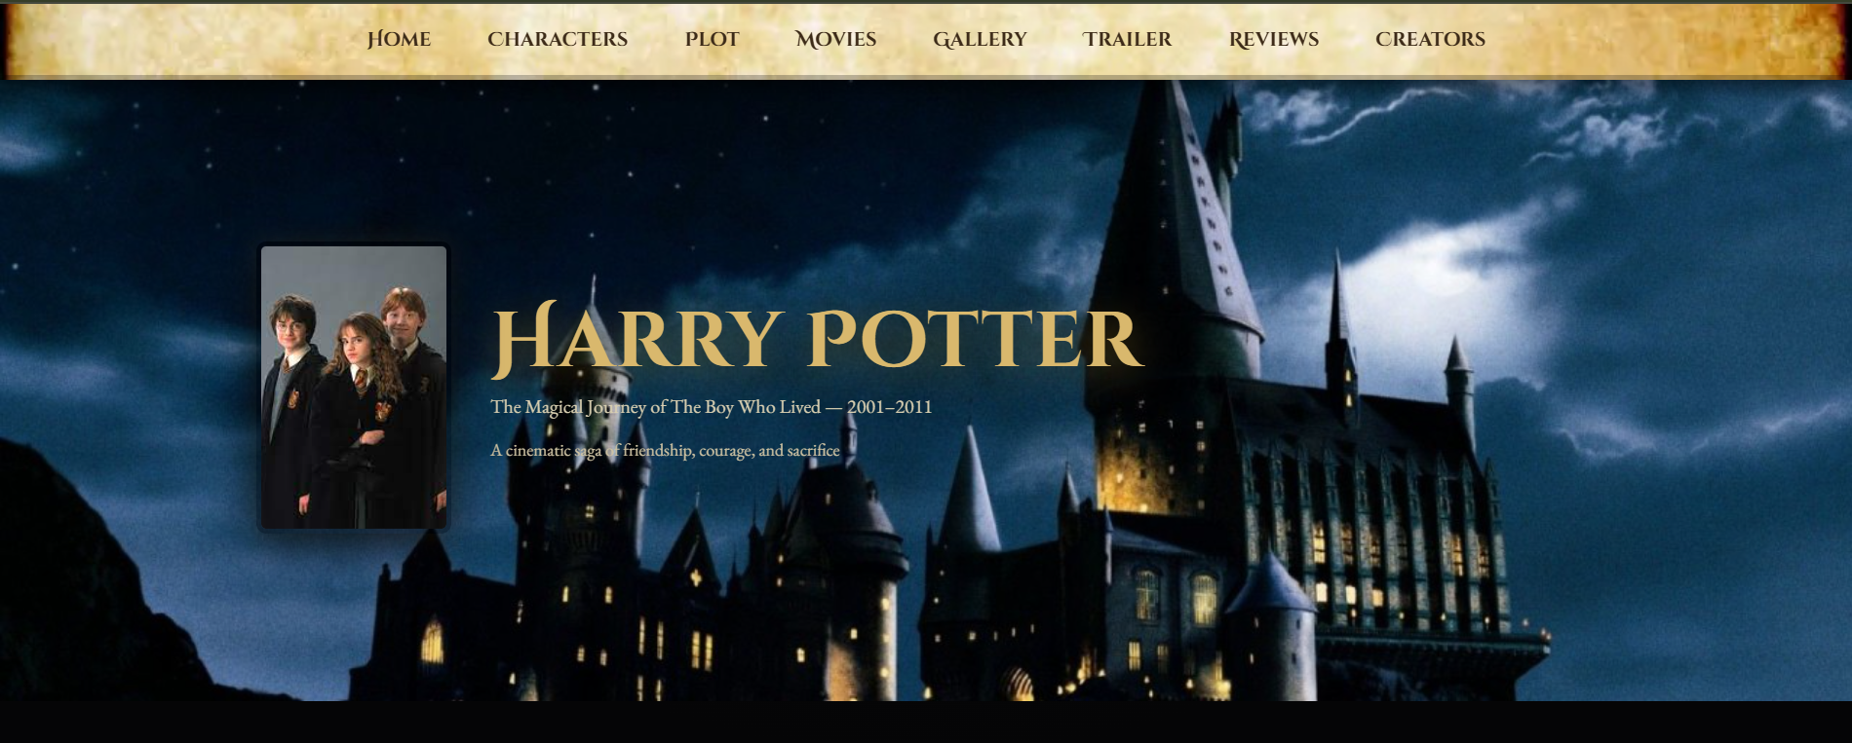 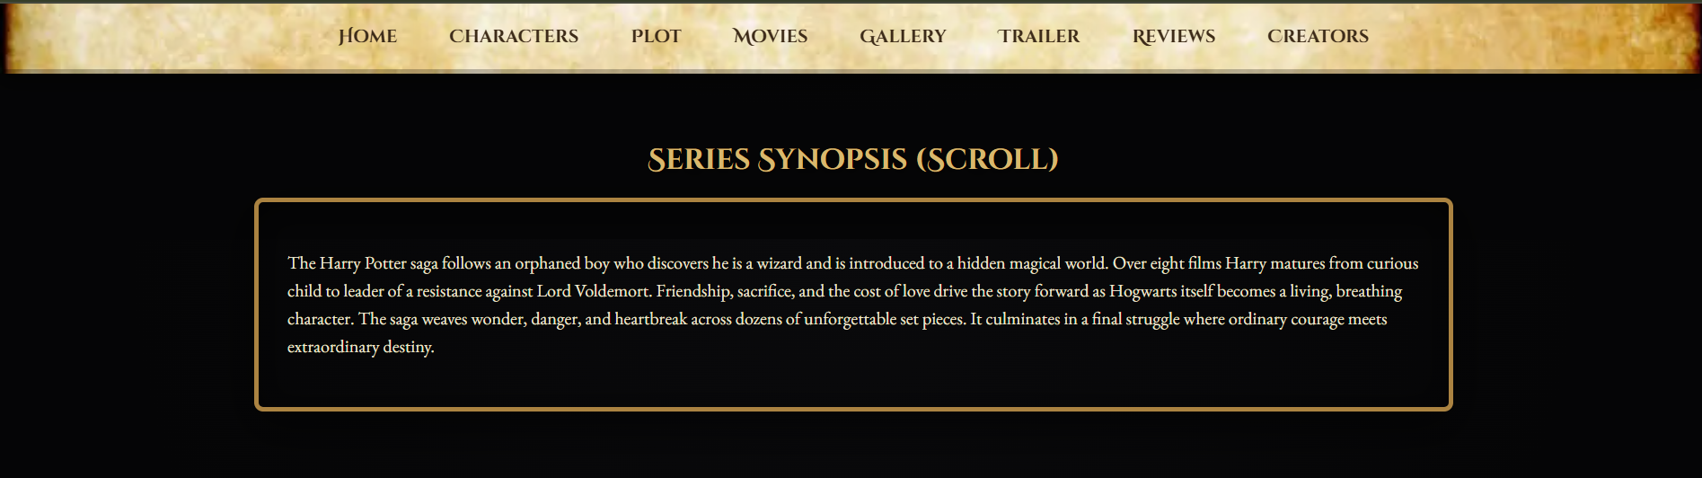

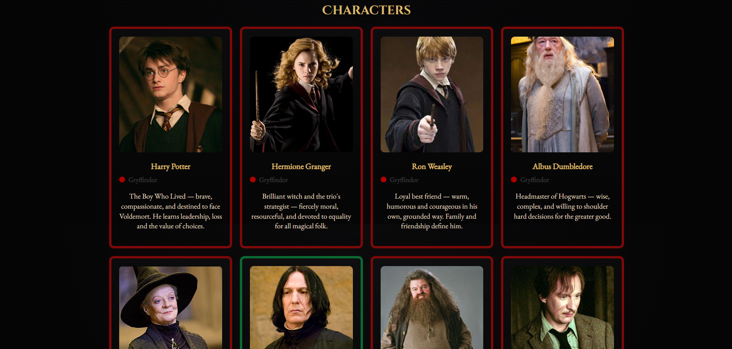 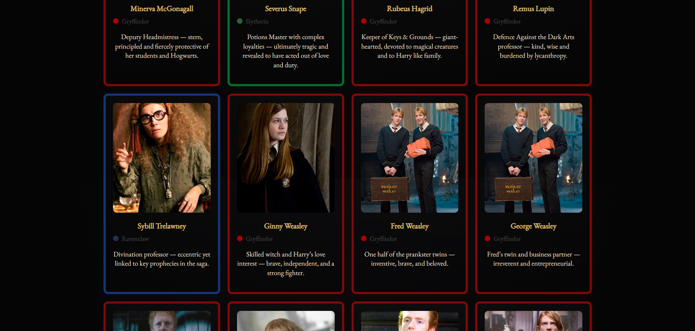

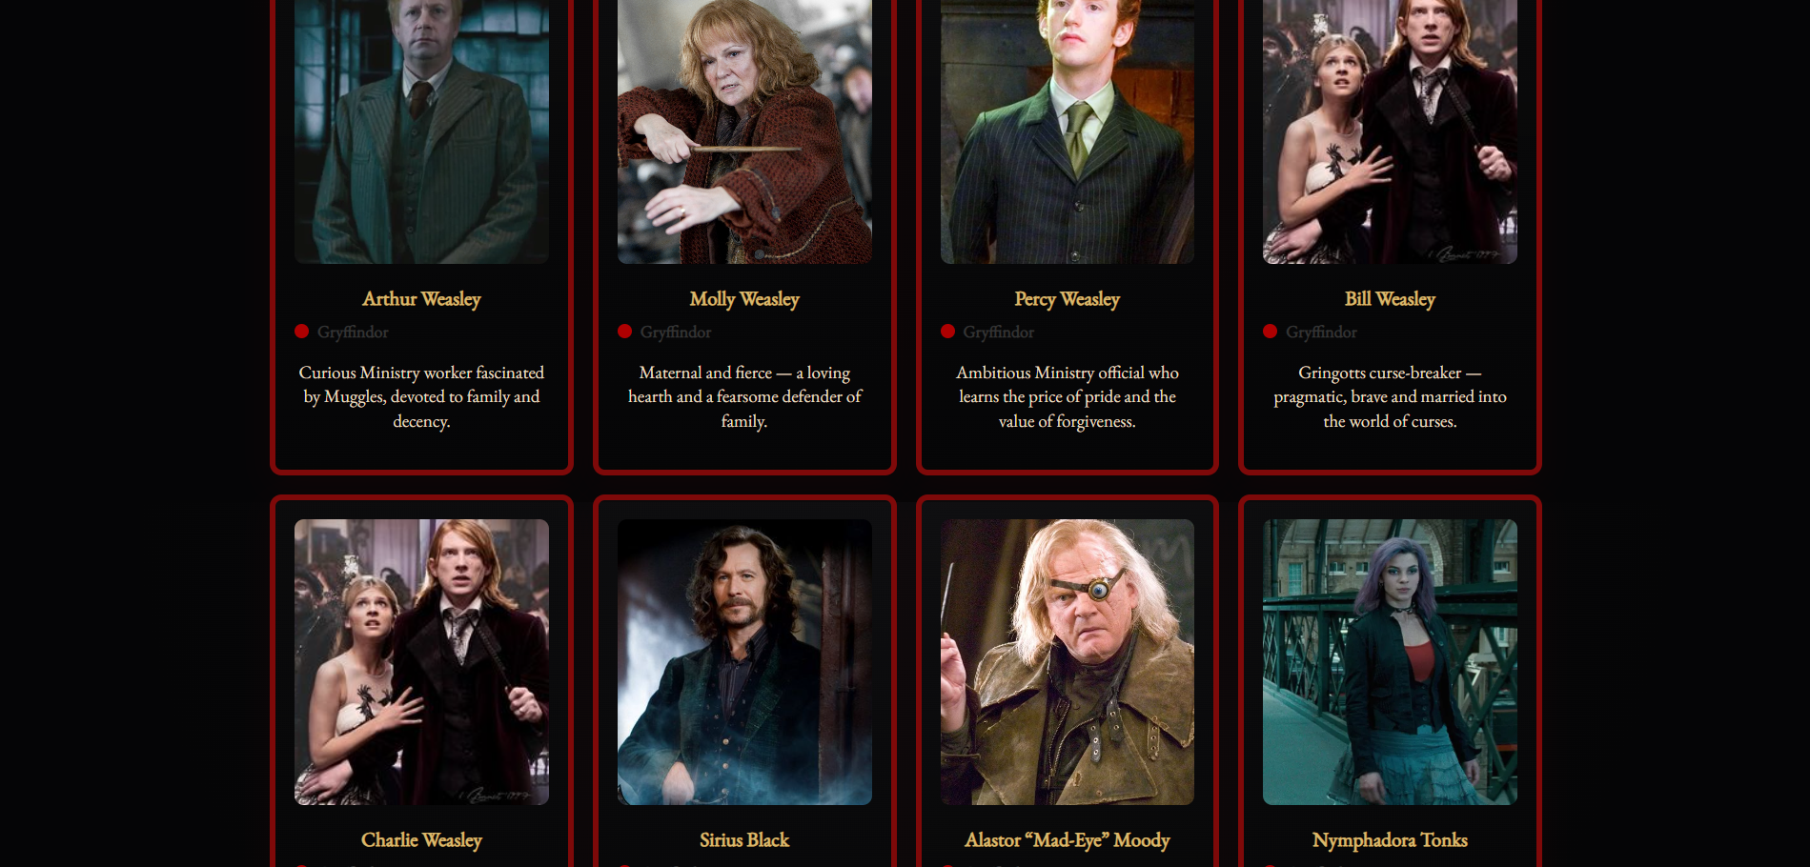 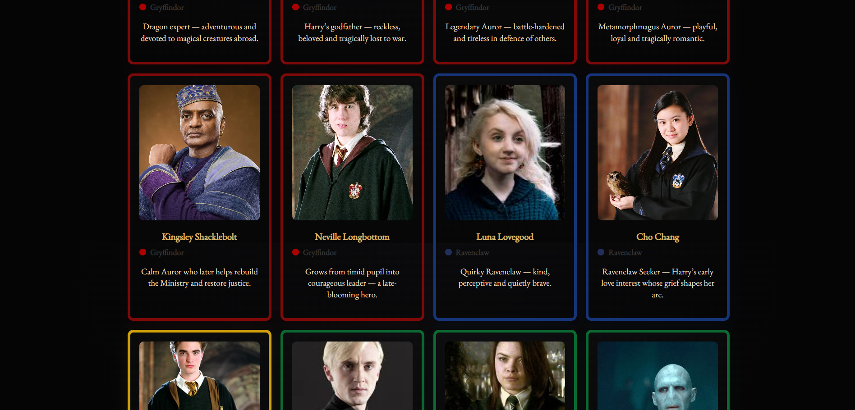

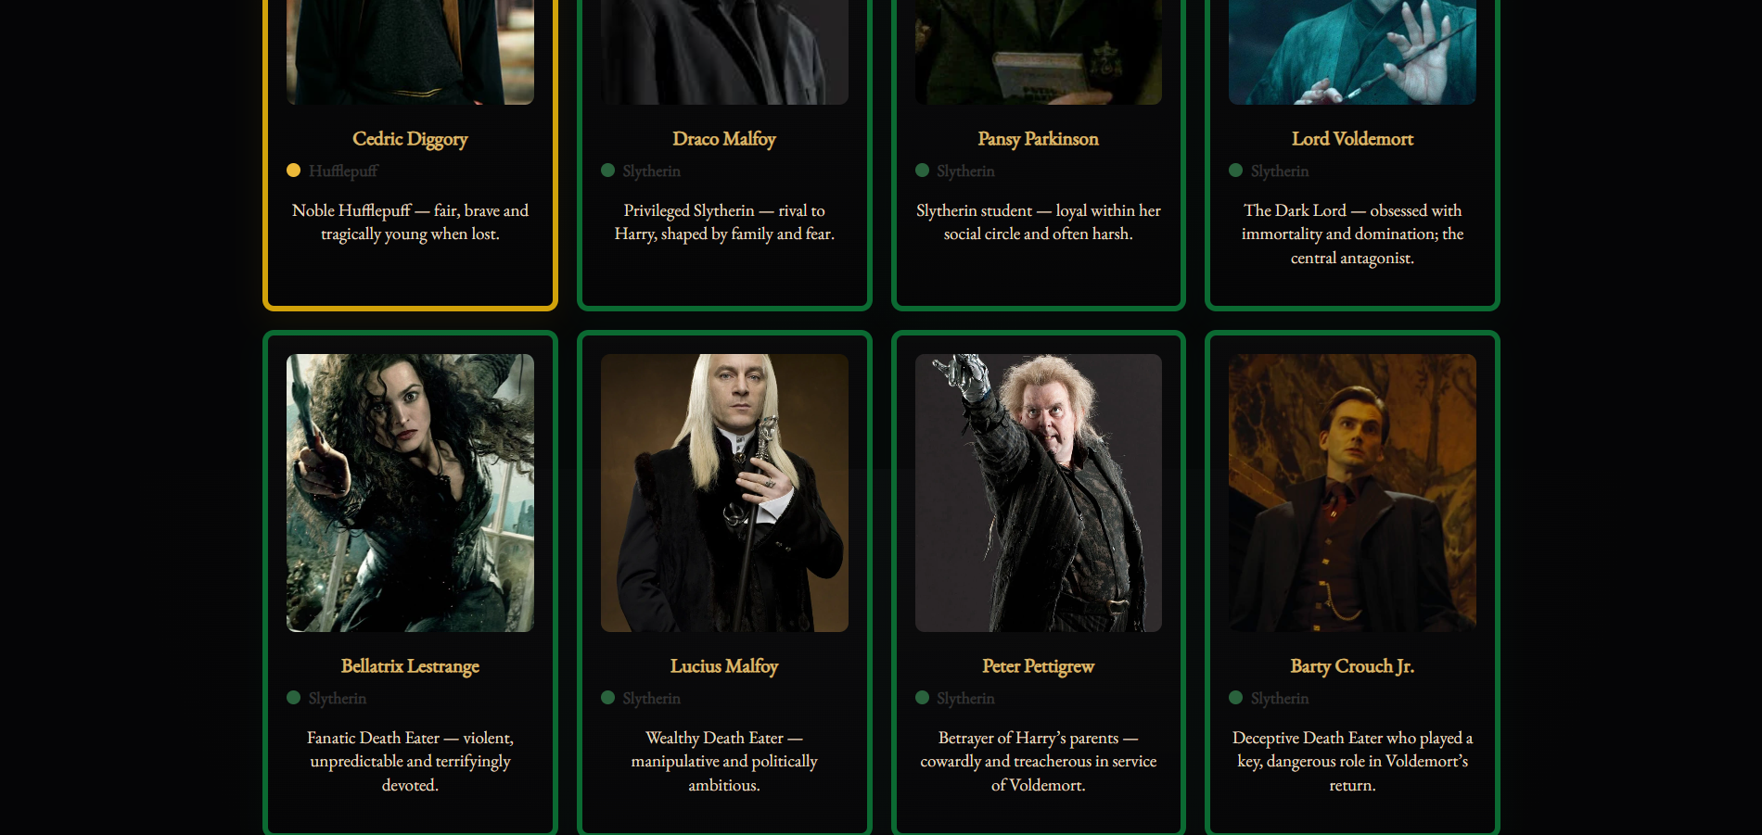 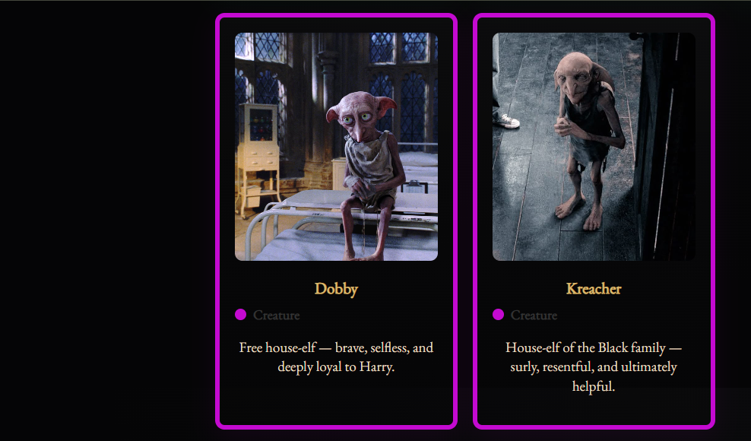

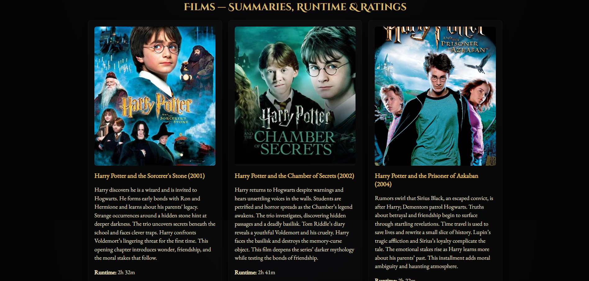 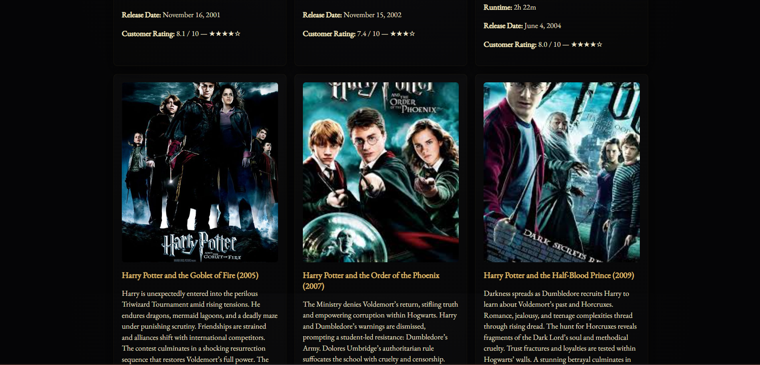

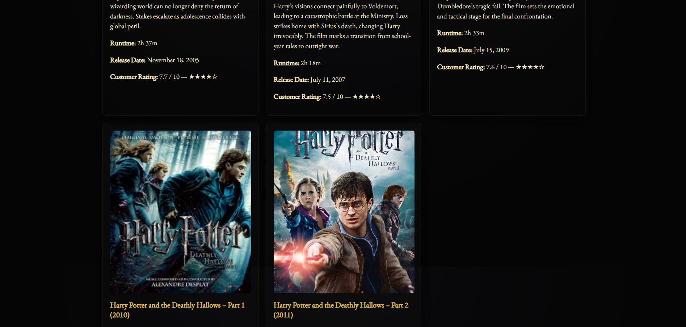 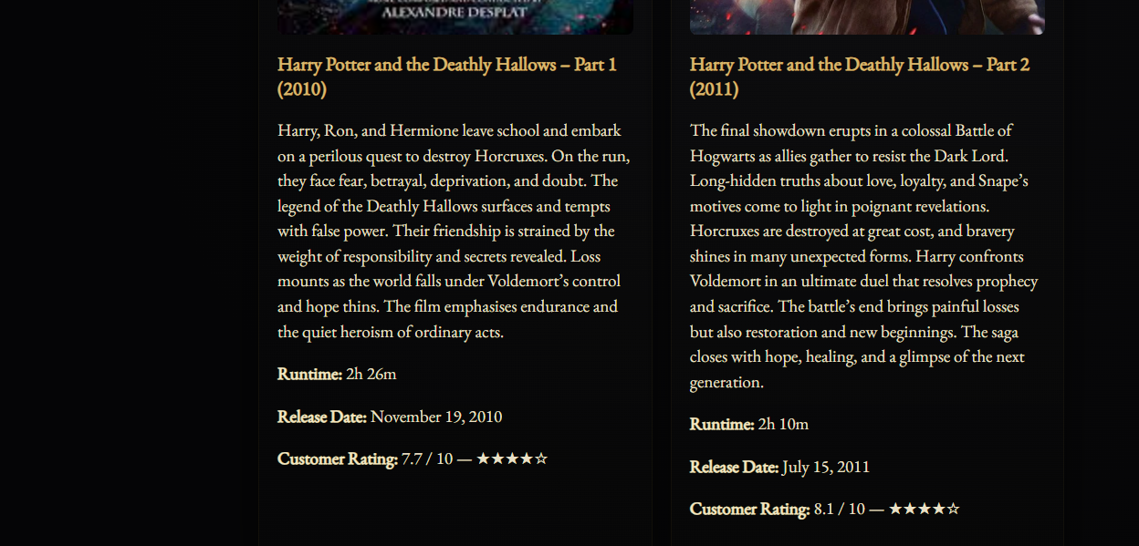

 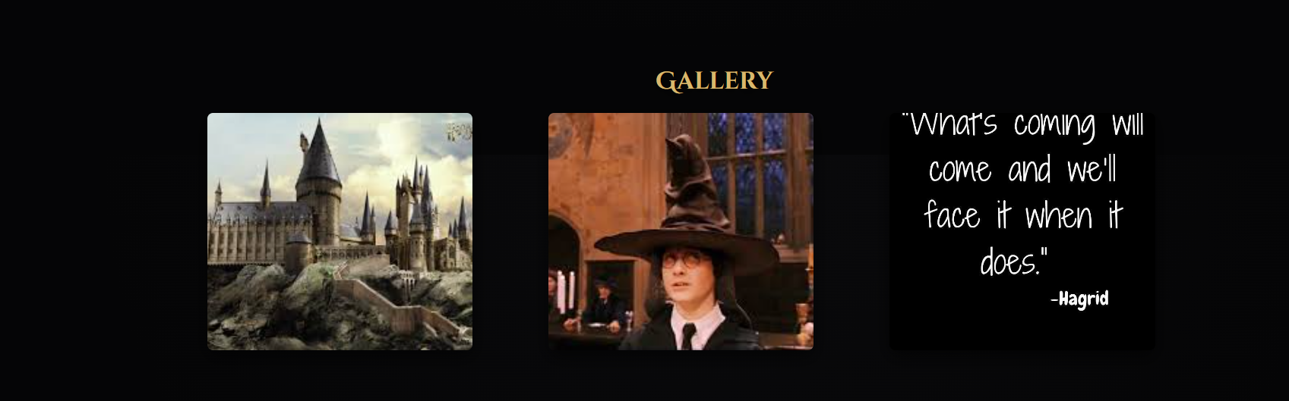

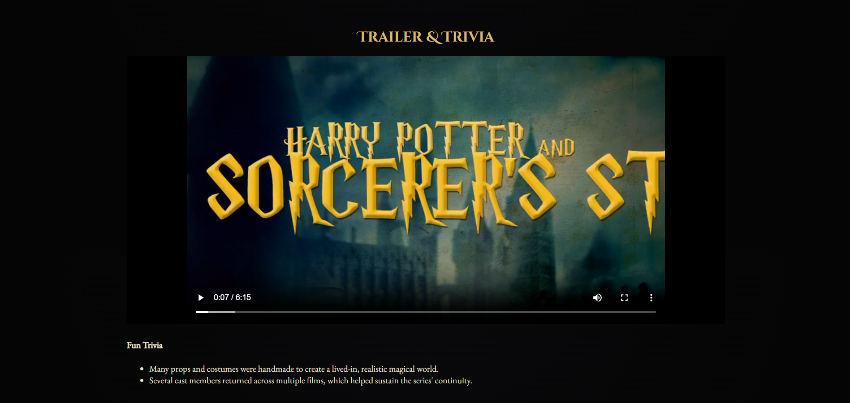 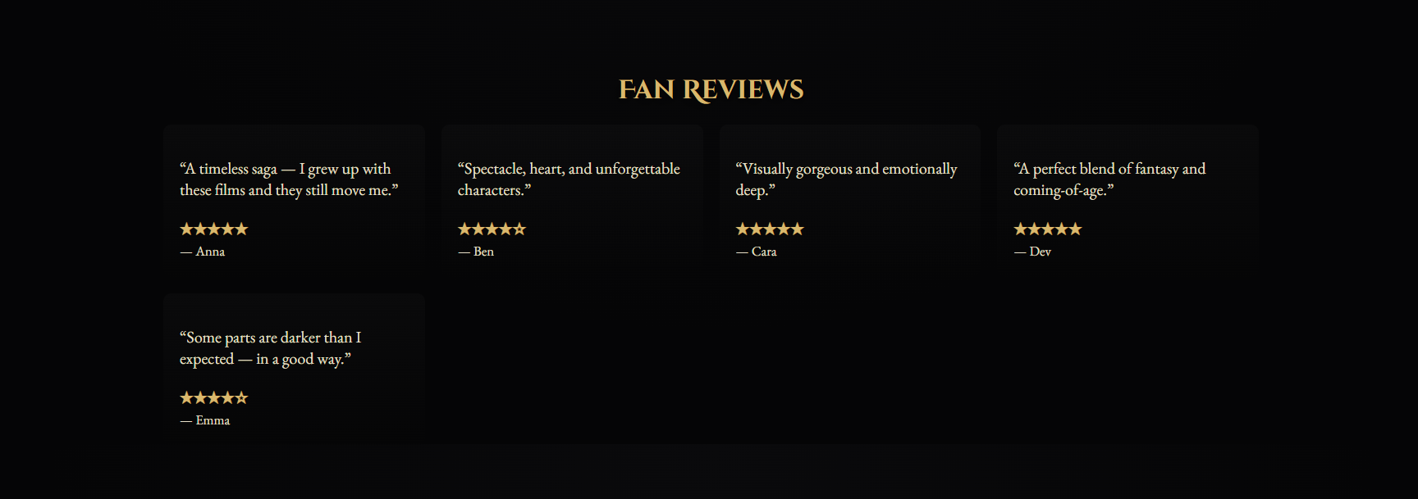

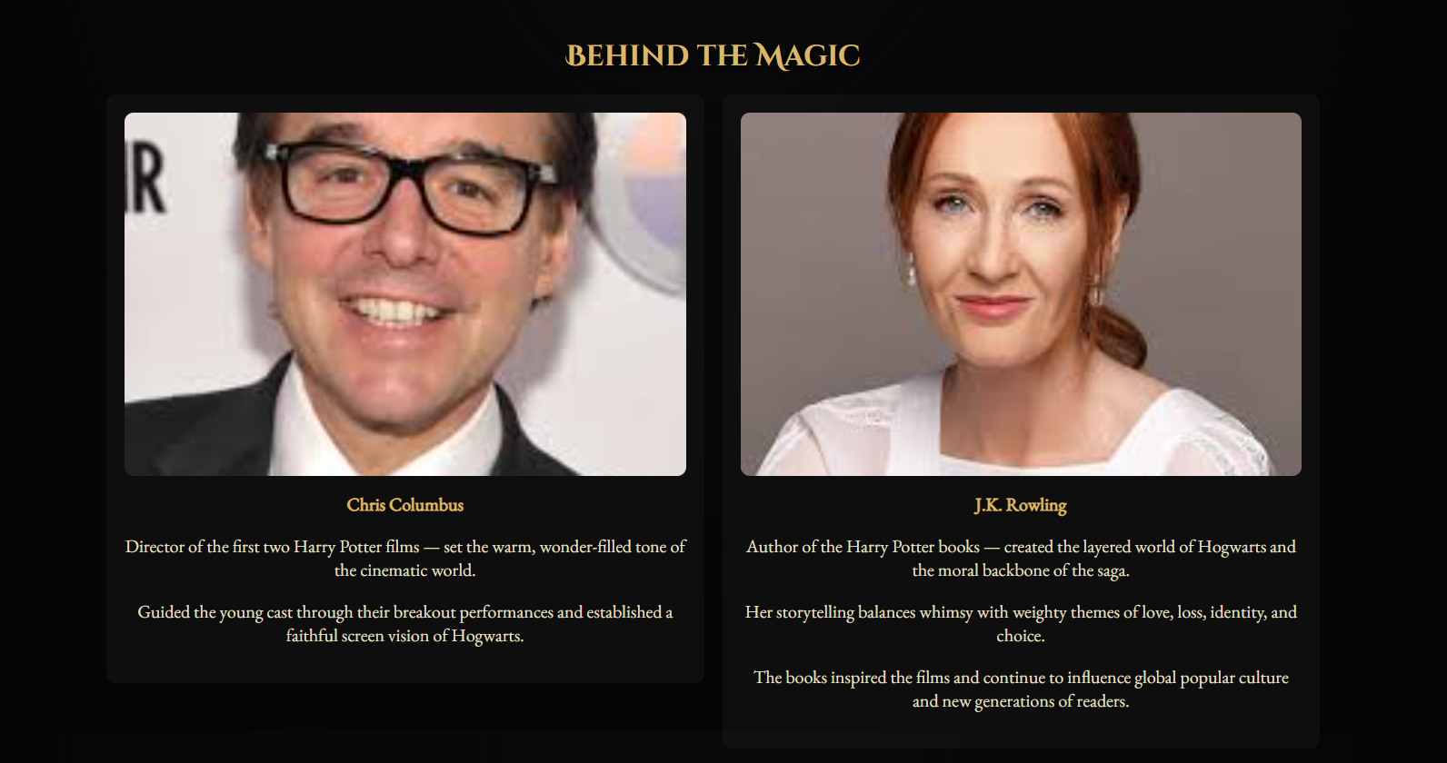 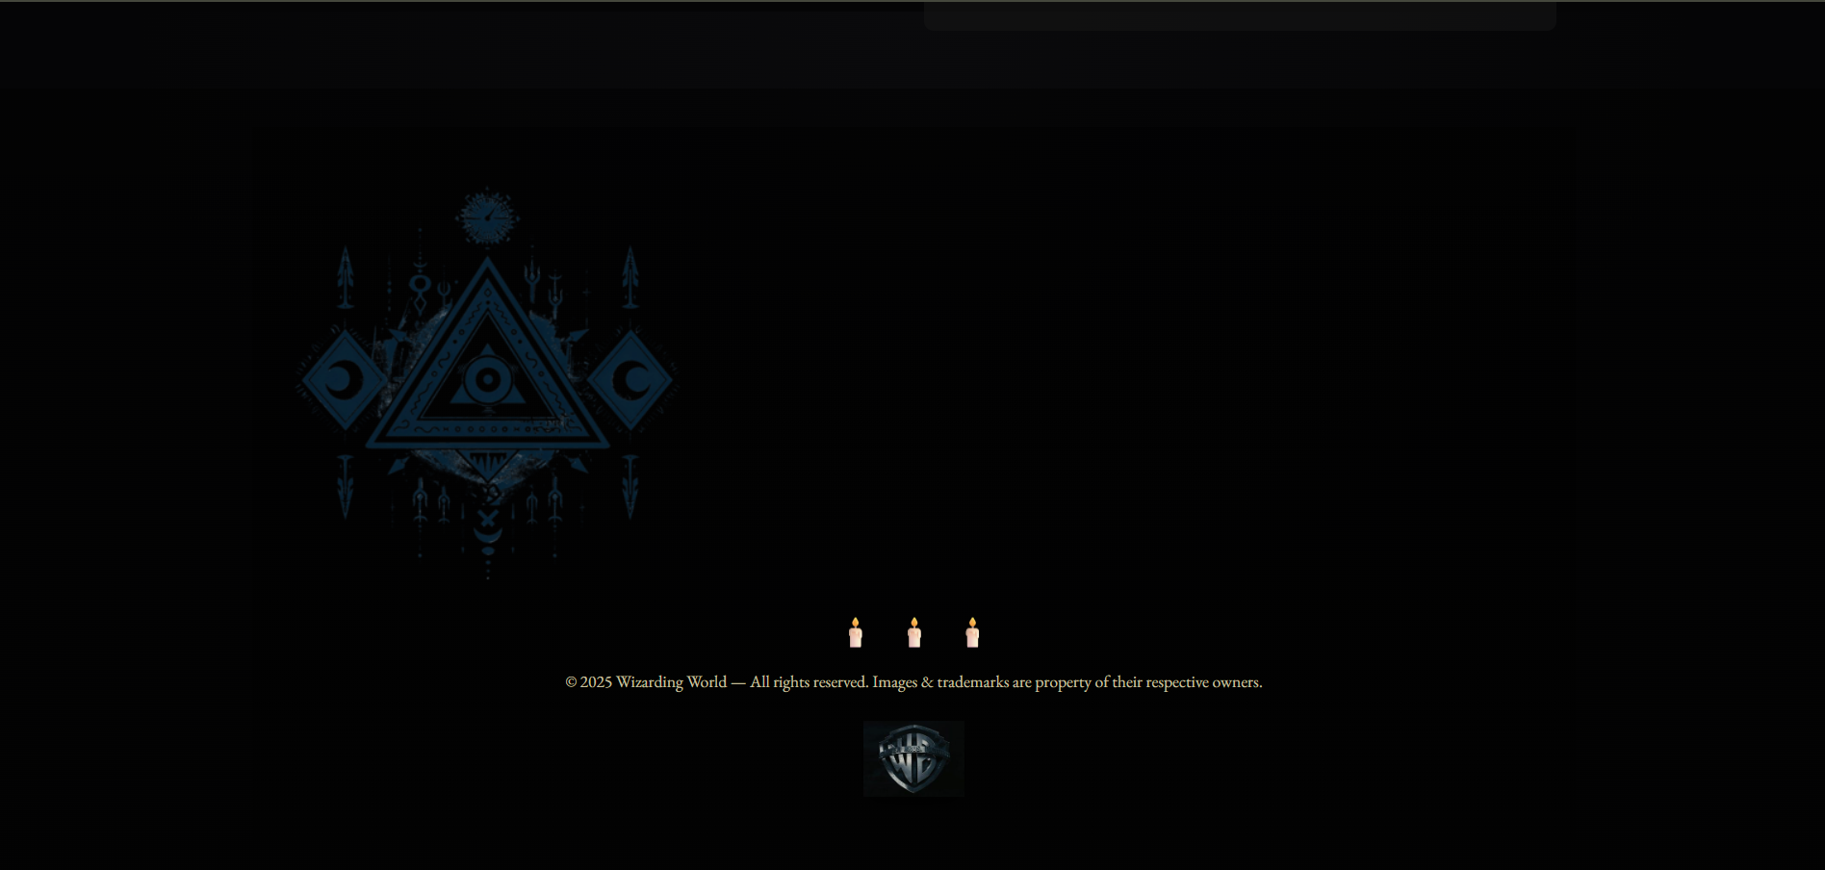

# 13. Conclusion

The Harry Potter Movie Series Info Page successfully brings the magic of the Wizarding World into a modern, responsive web experience. By combining thematic design elements, rich multimedia content, and a well-structured layout, the project delivers both aesthetic appeal and informative value. It not only showcases the complete series in an engaging manner but also demonstrates strong front-end development skills using **HTML5, CSS3, Flexbox, and Grid.** This project serves as a creative example of how storytelling and technology can merge to create an immersive user experience for fans worldwide.

# 13. Reference

* **Harry Potter Official Website** – https://www.wizardingworld.com (for movie details, official images, and character info
* **IMDb – Harry Potter Series** – <https://www.imdb.com> (for cast lists, release years, and reviews)
* **Wikipedia – Harry Potter Films** – https://en.wikipedia.org/wiki/Harry_Potter_(film_series) (for synopses and production details)
* **Google Fonts** – https://fonts.google.com (for Harry Potter-style typography)
* **CSS Tricks** – https://css-tricks.com (for layout and styling tips, including Flexbox and Grid)
* **Unsplash & Pixabay** – https://unsplash.com / https://pixabay.com (for free thematic background images)